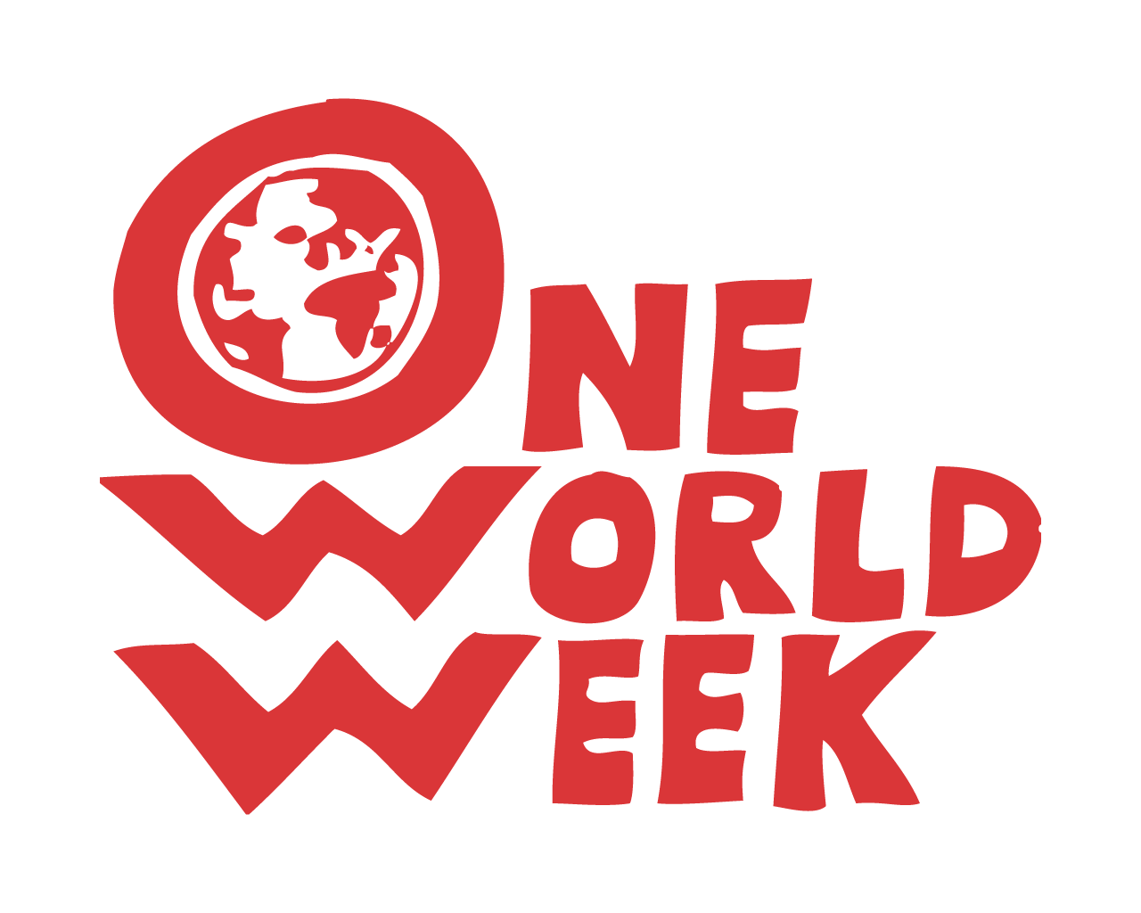

This Resource is a chart to explore various issues interrelated with climate change which might be the subject of OWW events or activities this October.

We found it useful when developing the theme, so thought organisers might find it helpful too!

N.B. - We have tried to keep it ‘jargon’ free but have provided a glossary on the last page for underlined terms in the text which may be new to some people. There is also a link there to the BBC’s Climate Change Dictionary.

ONE WORLD WEEK 2019 CLIMATE CHANGES EVERYTHING – THE TIME TO ACT IS NOW

ISSUE | OUTCOMES | CAUSES | SOLUTIONS | POSSIBLE CAMPAIGNS/ACTIONS
Climate change  (URGENCY see as a separate issue below) | Floods; Fires; Storms;  Droughts - Changes in seasonal patterns; crop failures. More extreme events; Water stress;  Loss of land and infrastructure;  Areas becoming uninhabitable; etc.  (see chart in leaflet) | Greenhouses gases:  oil-based economy,  use of coal and gas,  high demand for livestock which emit methane,  Over-consumption in general;  Reduction of forest cover and other carbon sinks.  + Tipping points | Cutting carbon,  Green energy,  Using less energy,  Changing diet,  Transport,  Energy efficient housing,  Plant trees,  Restore wetlands,  Resilient infrastructure e.g. flood management. | Testimonies/witnesses  Linking climate change and migration  Calling for green investment and showing examples e.g. Green New Deal  Pressure on politicians  Divestment from fossil fuels.  Challenging carbon heavy investment like fracking, new airports.  Dietary change,  Focus on our children’s future.
Species Loss | Break down of ecosystems,  Food shortages due to pollination failures,  Disease – due to loss of potential medical remedies | Loss of habitats to mining and forest clearance for agriculture;  Climate change (too fast for adaptation);  Pesticides;  Hunting; over-fishing;  Knock-on effects as species, including humans, depend on each other. | Acknowledging and factoring-in environmental costs.  Awareness/respect.  Habitat protection.  Environmental protection.  Showing inter-connections.  Restore half the planet to wild nature. | Supporting environmental protection  Habitat regeneration and creation  Diet  Farming methods  Tree-planting.  Encouraging farmers to return land to nature.
Planetary boundaries | Shortages of food and  raw materials.  Exceeding capacity to absorb waste. | Inadequate economic model  Over-consumption; Population;  Wasteful manufacturing practices,  Poor recycling,  Planned obsolescence. | Include environmental costs;  New approach to manufacturing  and consumption:  Circular economy. | Challenging economists to rethink growth: Doughnut Economics; Economy for the Common Good  Case studies of good examples.  Looking at lifestyles.
Poverty | Suffering.  Migration. | Inequality  Climate change  Loss of land to inappropriate land uses: industrial farming and mining;  Unfair trade  Debt traps | Sustainable Development Goals – clear targets; Sustainable livelihoods/living incomes;  Challenging inequality.  Happiness/well-being and common good to replace Gross National Product as criterion for national success.  Increased local autonomy. | Trade deals; Climate justice; Debts;  Money for adaptation, mitigation and reconstruction;  Fairtrade and climate.  Empowerment.
ISSUE | OUTCOMES | CAUSES | SOLUTIONS | POSSIBLE CAMPAIGNS/ACTIONS
Migration | Nationalism, xenophobia, racism.  Hostile environment.  Growth of refugees’ camps. | Wars and conflict; persecution.  Climate change;  Poverty: unemployment,  Expropriation of land and water for mining and industrial agriculture. | Showing inter-connectedness at the global, international level;  Sharing responsibility and working together to save humanity.  At local level - acknowledging and sharing our humanity. | Stories behind climate migrants;  Joint actions locally (e.g. Cities of Sanctuary);  Support for and from international groups
Pollution/Air quality | Ill-health;  Low quality of life;  Species loss. | Vehicle emissions,  Fossil fuels.  Lack of controls.  Insufficient investment. | Transport/shipping  Air travel  Strict controls on industry  Phasing out fossil fuels (coal, gas (cease fracking) oil)  Switch to clean energy.  Plant trees | Campaigns on plastics and air quality.  Cutting emissions,  Opposing airport expansion,  Opposing fracking  Promoting clean energy fuelled public transport.
Inequality | Injustice: rich emit greenhouse gases -, poor suffer consequences | Tax avoidance;  Neoliberal right-wing ideas:  Failure of democracy leading to concentration of power;  Lack of local autonomy | Participatory democracy;  Redistributive policies;  Safety net. | Tax campaigns  Challenging power of Corporations;  Fair trade deals.  Debt.  System change
URGENCY  Lack of adequate response to the need for rapid change – too slow / not sufficient | Serious threat to planet’s ability to support current species and projected populations.  Risk of uncontrollable change as Tipping points are reached.  Student strikes;  Panic;  Civil unrest;  Mental health. | Majority of people/ media  /organisations / politicians /businesses do not know how serious it is.  We are in comfortable but fatal denial.  Media not telling it how it is.  Distractions – poor (and governments) are focussed on survival now;  More interest in money and  maintaining the system and the status quo. | Communicate:  - the current impacts on ecosystems and communities around the world;  - the risks of inadequate action to the future generations;  Change the economic system:  challenge fixation on growth;  live within planetary limits; require organisations to work for the common good.  Raise targets and act more quickly on all the above solutions. | Get people thinking about Climate Change impacts and risks of not making the appropriate changes NOW.  Watch Attenborough programme – ‘Our Planet’ (Netflix) or ‘Climate Change’ (BBC).  Offer actions so people feel they can do something (instead of feeling helpless and hopeless and getting depressed.)  - Stress lifestyle and health benefits of greener living and the excitement of new technologies.  - The Government and many councils have agreed we have a climate emergency. Has yours? What can you do to push them into faster action?
GLOSSARY

The circular economy recognises that our current traditional linear economy, which has a 'take, make, dispose' model of production is extracting resources faster than the planet can regenerate them and creating waste faster that the planet can absorb it. A circular system reduces the consumption of finite resources by designing waste out of the system by making products to last (through long-lasting design, maintenance, repair, reuse, remanufacturing, and refurbishing, ) then reuses and recycles “waste” materials to make new products. It is based on 3 principles:
      - Design out waste and pollution
      - Keep products and materials in use
      - Regenerate natural systems

Proponents of the circular economy suggest that a sustainable world does not mean a drop in the quality of life for consumers and can be achieved without loss of revenue or extra costs for manufacturers. The argument is that circular business models can be as profitable as linear models, allowing us to keep enjoying similar products and services. Sources: Wikipedia; Ellen Macarthur Foundation; this video captures the excitement!
Doughnut Economics is a wake-up call to transform our capitalist worldview obsessed with growth into a more balanced, sustainable perspective that allows both humans and our planet to thrive.
Kate Raworth, author of the book “Doughnut Economics – 7 ways to think like a 21st century economist” explains in 7x2 minute videos https://www.kateraworth.com/animations/
Economy for the Common Good is a vision of a fairer society based on inclusive democratic participation, building an economy that increases the wellbeing of everyone and which protects our environment for future generations. Success would be measured in terms of contributions to the common good rather than profits for shareholders. (More on this from the OWW information sheet: “Our Changing World - Sources of information about some key ideas and facts.”)
Green New Deal is a US congressional resolution that lays out a grand plan for tackling climate change. Introduced by … Democrats, the proposal calls on the federal government to wean the United States from fossil fuels and curb planet-warming greenhouse gas emissions across the economy. It also aims to guarantee new high-paying jobs in clean energy industries.
(Source: Lisa Friedman, New York Times, 11 Feb 2019 (https://www.nytimes.com/2019/02/21/climate/green-new-deal-questions-answers.html )
(More here: https://en.wikipedia.org/wiki/Green_New_Deal)
Planned obsolescence is a policy of designing a product with an artificially limited useful life, so that it becomes obsolete (i.e., unfashionable, or no longer functional) after a certain period of time. The aim is to generate long-term sales volume by reducing the time between repeat purchases. (Source: Wikipedia)

A Tipping point is a threshold for change, which, when reached, results in a process that is difficult to reverse. Describes how the climate may suddenly change after passing a ‘tipping point’, making it even harder to stop or reverse. Scientists say it is urgent that policymakers halve global carbon dioxide emissions by 2030 or risk triggering changes that could be irreversible.
Climate Change Dictionary BBC 2019 ( https://www.bbc.co.uk/news/science-environment-48057733 ) is useful for scientific terms related to climate change.

